SKU：110061362

Short description
Jetson-10-1-A0 is a hand-size edge AI box built with Jetson Nano module, rich set of IOs, aluminium case, passive heatsink, pre-installed JetPack System, ready for your next AI application development and deployment.

PRODUCT DETAILS
Note:
- We will not include a power cord, please choose a suitable form according to your country.
- We will not include a 3V RTC battery (2-pin).

Features

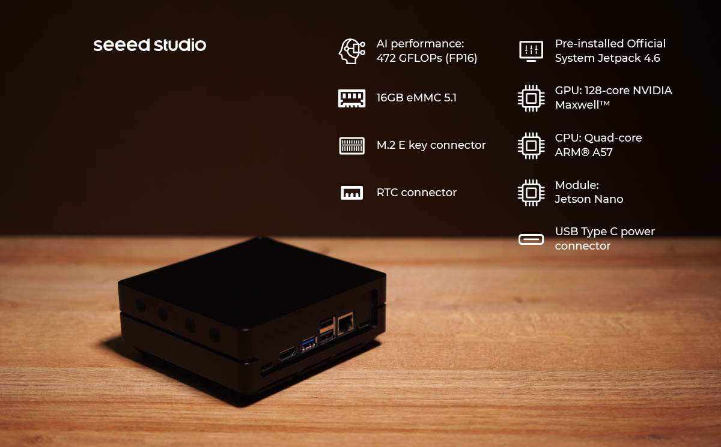

- Hand-size edge AI device with an overall dimension of 130mm*120mm*50mm, fits in everywhere.
- Powered by the quad-core ARM® Cortex®-A57 MPCore processor.
- 128-core NVIDIA Maxwell™ GPU with 128 NVIDIA CUDA® cores delivers 0.5 TFLOPs (FP16).
- Rich peripherals including Gigabit Ethernet port, USB 3.0 and USB 2.0 Type-A ports, HDMI port.
- Pre-installed NVIDIA official JetPack software, ready for cloud native application.
- Able to mount on the wall, mounting holes on the back.
- Support wide range of AI application fast building with our ecosystem partners.
- Support Allxon to enable efficient remote hardware management services.

Note:
- We have already installed JetPack 4.6 system.

Description
reComputer Jetson series are compact edge computers built with NVIDIA advanced AI embedded systems: Jetson-10 (Nano) and Jetson-20 (Xavier NX). With rich extension modules, industrial peripherals, thermal management combined with decades of Seeed’s hardware expertise, reComputer Jetson is ready to help you accelerate and scale the next-gen AI product emerging diverse AI scenarios.
reComputer Jetson is compatible with the entire NVIDIA Jetson software stack, cloud-native workflows, industry-leading AI frameworks, helping deliver seamless AI integration.

Application: For next-gen autonomous machine
With edge AI developers can deploy machine learning models in solving demanding challenges for advanced robotics and autonomous machines in the fields:
Edge AI into the Wild: UAV, Drone, Wildlife protection,Agriculture
Smart City: Traffic,Retail, Healthcare
Industry 4.0:Manufacturing, Logistics, Deliver, Service
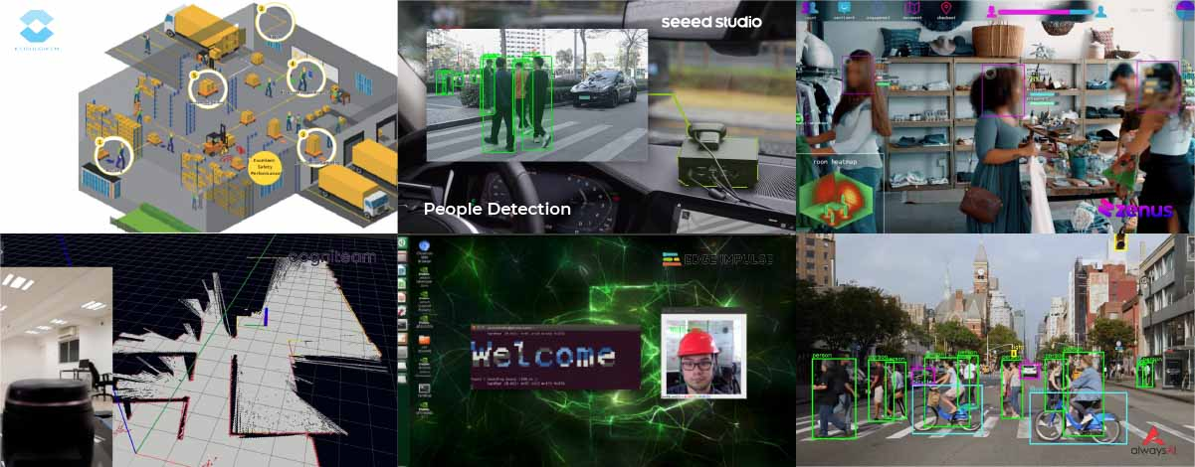

Comparison between Nano 2GB developer kit and Jetson-10-1-A0：
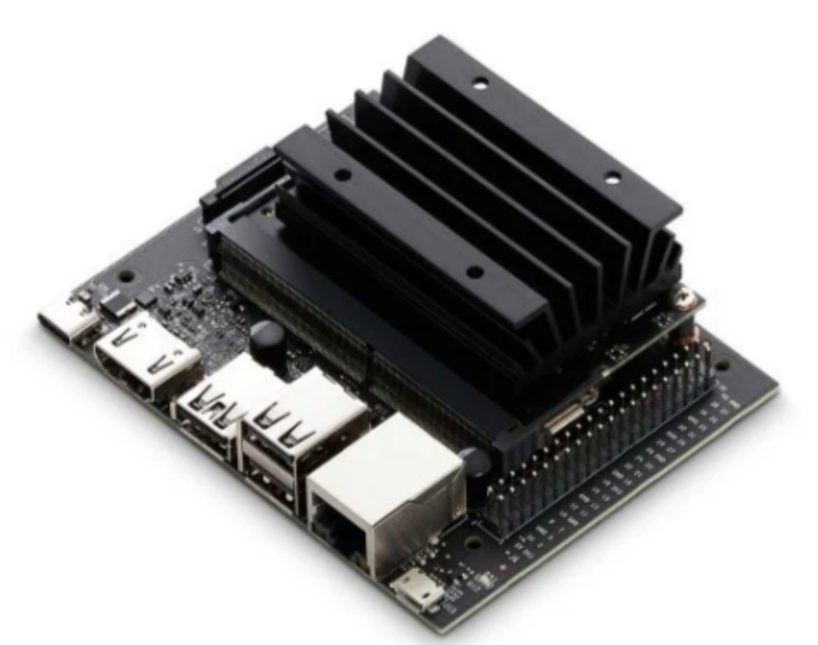 | 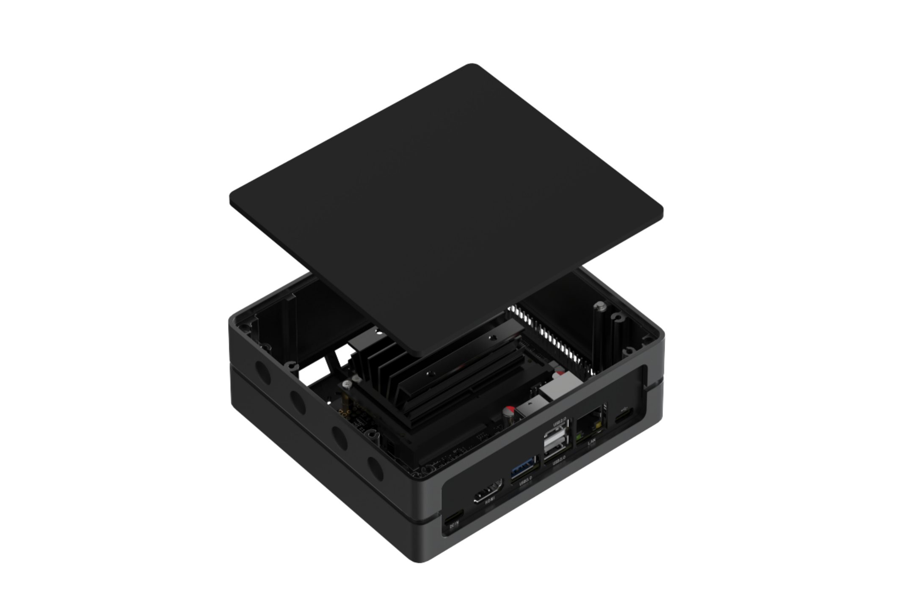
NVIDIA® Jetson Nano™ 2GB Developer Kit | reComputer Jetson-10-1-A0
Nano (not production version) | Nano (production version)
472 GFLOPS
128-core NVIDIA Maxwell™
Quad-core ARM A57 @ 1.43 GHz
2GB 64-bit LPDDR4 25.6GB/s | 4GB 64-bit LPDDR4 25.6GB/s
microSD (Card not included) | 16 GB eMMC
4Kp30 | 4x 1080p30 | 9x 720p30 (H.264/H.265) | 4K30 | 2x1080p60 | 4x1080p30 |  4x720p60 | 9x720p30 (H.265 & H.264)
4Kp60 | 2x 4Kp30 | 8x 1080p30 | 18x 720p30 (H.264/H.265) | 4K60 | 2x 4K30 | 4x 1080p60 | 8x 1080p30 | 9x 720p60  (H.265 & H.264)
1*RJ45 Gigabit Ethernet Connector (10/100/1000)
1 * USB 3.0 Type A Connector;  2 * USB 2.0 Type A Connector;  1 * Micro-USB port for Device mode;  1 * USB Type C for 5V power input | 1 * USB 3.0 Type A Connector;  2 * USB 2.0 Type A Connector;  1 * USB Type C for Device mode;  1 * USB Type C for 5V power input
1*CSI Camera (15 pos, 1mm pitch, MIPI CSI-2 ) | 2*CSI Camera (15 pos, 1mm pitch, MIPI CSI-2 )
1*HDMI Type A
- | 1* FAN(5V PWM)
- | 1*M.2 Key E
- | -
- | 1*RTC Socket
1* 40-Pin header
USB-Type C 5V⎓3A；
100 mm x 80 mm x 29 mm | 130 mm x 120 mm x 50 mm(with case)

Power-efficient AI computer, compact rich I/Os for Endless AI possibilities:
reComputer Jetson - 10 comes with Jetson Nano delivers 0.5 TFLOPs (FP16), making it ideal for high-performance compute and AI in embedded and edge systems. You get the performance of 128 NVIDIA CUDA® Cores, quad-Core ARM CPUs. Combined with over 25.6GB/s of memory bandwidth, video encoded and decoded, these features make Jetson Nano the platform of choice to run multiple modern neural networks in parallel and process high-resolution data from multiple sensors simultaneously.
Now, you can innovate at the edge with powerful and efficient AI, computer vision, and high-performance computing at just 5 to 10 watts.

Powerful reference carrier board :
Seeed reference carrier board for Jetson-10-1-A0 is a high-performance, interface rich NVIDIA Jetson Nano compatible carrier board, providing HDMI 2.0, Gigabit Ethernet, USB 3.0, USB 2.0, CSI camera, GPIO, I2C, I2S, fans, and other rich peripheral interfaces. It has nearly the same functional design and size as the carrier board of NVIDIA Jetson Nano 2GB Developer Kit | NVIDIA Developer.
Take advantage of the small form factor, sensor-rich interfaces, and big performance to bring new capability to all your embedded AI and edge systems.

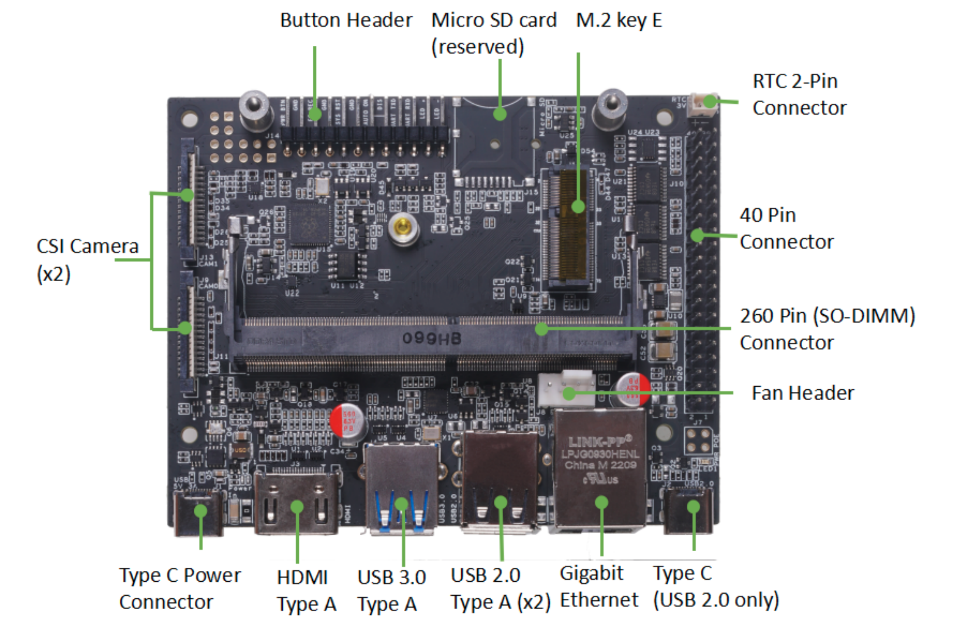

Desktop, Wall Mount, or fit in anywhere
With an overall dimension of 130mm*120mm*50mm, it is only around 1/10 of the size of an ordinary computer case which makes it possible to fit in edge AI scenarios. The back screw holes allow you to hang the product as you need. We also provide other editions case like blue, silver and silver mental, whose stackable structure allows you to stack more middle layers to create rooms very easily.

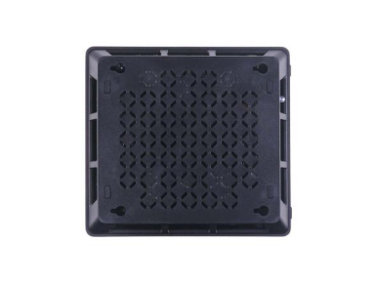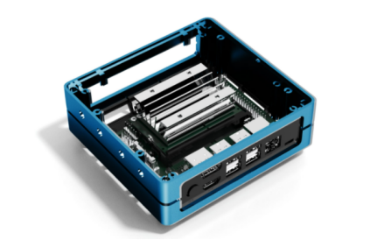

Prebuild system for edge AI integration
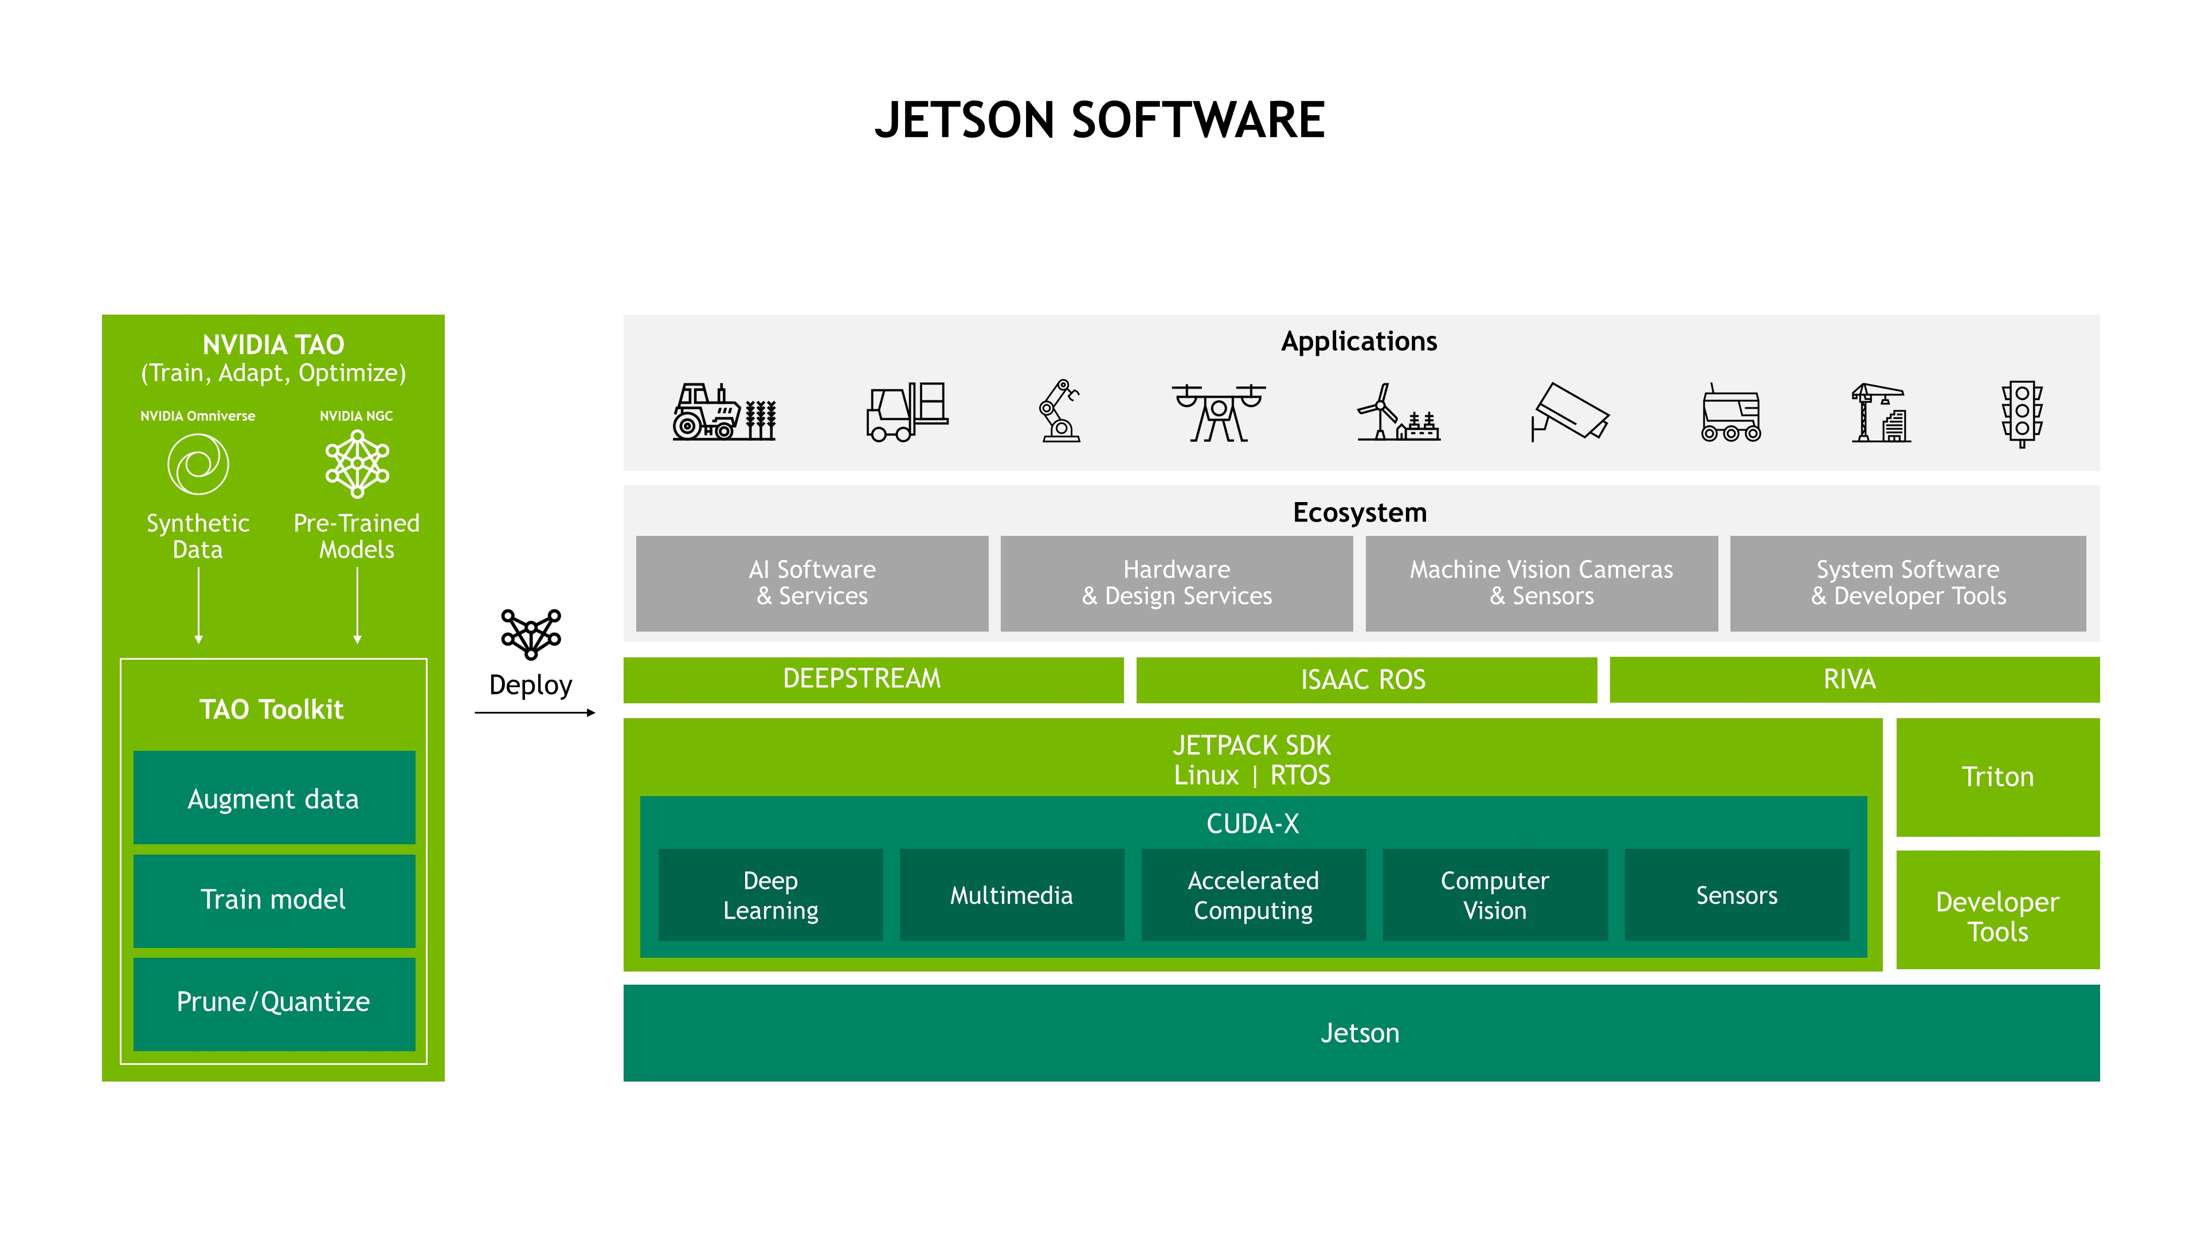
All NVIDIA® Jetson™ modules and developer kits are supported by the same software stack, enabling you to develop once and deploy everywhere. Jetson Software is designed to provide end-to-end acceleration for AI applications and accelerate your time to market. We bring the same powerful NVIDIA technologies that power data center and cloud deployments to the edge.
NVIDIA JetPack includes NVIDIA Container Runtime with Docker integration, enabling GPU accelerated containerized applications on Jetson platform. Jetpack also brings support for NVIDIA Triton™ Inference Server to simplify the deployment of AI models at scale.

NVIDIA Jetson powered Edge AI platform at Seeed
At Seeed, you will find everything you want to work with NVIDIA Jetson Platform – official NVIDIA Jetson Dev Kits, Seeed-designed carrier boards, and edge devices, as well as accessories.
Seeed will continue working on the Jetson product line and will be ready to combine our partners’ unique technology with Seeed’s hardware expertise for an end-to-end solution.

Work with Seeed Ecosystem

Deploying an AI idea can be faster, flexible, even scalable for everyone. Seeed Jetson Platform targets on helping educators, developers and enterprises deploy ML in the real-world. By consolidating Seeed’s best-in-class hardware, cutting-edge technology from our software partners and all developers from the community, we aim at emerging all kinds of AI scenarios in our open-source platform to faster industries digital transformation. We are looking for partners to join our ecosystem together to deliver solutions to different industries together. Please contact cooperation@seeed.cc for more partnership ecosystem information.

Specifications

Module Technical Specifications
GPU | NVIDIA Maxwell™ architecture with 128 NVIDIA CUDA® cores  0.5 TFLOPs (FP16)
CPU | Quad-core ARM® Cortex®-A57 MPCore processor
Memory | 4 GB 64-bit LPDDR4 1600MHz - 25.6 GB/s
Storage | 16 GB eMMC 5.1 Flash
Video Encode | 250 MP/sec  1x 4K @ 30 (HEVC)  2x 1080p @ 60 (HEVC)  4x 1080p @ 30 (HEVC)
Video Decode | 500 MP/sec  1x 4K @ 60 (HEVC)  2x 4K @ 30 (HEVC)  4x 1080p @ 60 (HEVC)  8x 1080p @ 30 (HEVC)
Camera | 12 lanes (3x4 or 4x2) MIPI CSI-2 DPHY 1.1 (18 Gbps)
Connectivity | Wi-Fi requires external chip
Connectivity | 10/100/1000 BASE-T Ethernet
Display | HDMI 2.0 or DP1.2 | eDP 1.4 | DSI (1 x2) 2 simultaneous
UPHY | 1 x1/2/4 PCIE, 1x USB 3.0, 3x USB 2.0
I/O | 1x SDIO / 2x SPI / 4x I2C / 2x I2S / GPIOs -> I2C, I2S
Size | 69.6 mm x 45 mm
Mechanical | 260-pin edge connector

Carrier Board Technical Specifications
Connector | Jetson-10-1-A0 | NVIDIA Jetson Nano 2GB Developer Kit | NVIDIA Developer
Jetson module connector | 1*Jetson SODIMM connector, 260-pin | 1*Jetson SODIMM connector, 260-pin
USB 3.0 | 1 * USB 3.0 Type A Connector | 4 * USB 3.0 Type A Connector
USB 2.0 | 2 * USB 2.0 Type A Connector  1 * USB 2.0 Type C Connector | 1 * USB Micro B, RA Female
Ethernet Port | 1*RJ45 Gigabit Ethernet Connector (10/100/1000) | 1*RJ45 Gigabit Ethernet Connector (10/100/1000)
Display Port | 1*HDMI Type A | 1*HDMI Type A and 1*DP
CSI Camera Connector | 2*CSI Camera (15 pos, 1mm pitch, MIPI CSI-2 ) | 1*CSI Camera (15 pos, 1mm pitch, MIPI CSI-2 )
M.2 Key E | 1*M.2 Key E Slot (75-pin) 2230 | 1*M.2 Key E Slot (75-pin) 2230
M.2 Key M | \ | \
Multifunctional Port | 2.0 Pitch 40 PIN | 2.0 Pitch 40 PIN
Button Header | 1*Button Header | 1*Button Header
FAN Connector | 1*Picoblade Header | 1*Picoblade Header
CAN | \ | \
Micro SD card | Reserved | \
RTC | Reserved | Reserved
Power | 1* Type-C connector | 1* Type-C connector

Part List
1 x Acrylic Cover
1 x Aluminium Frame
1 x Jetson Nano module
1 x Heatsink
1 x Carrier board

